Place value – charts and partitioning tool

Overview

This file enables you to explore the process of partitioning numbers into multiples of 1000, 100, 10, 1, 0.1, 0.01 and 0.001 as appropriate. You can start with a number and identify the value of the separate digits or start with the various multiples arranged in a place value chart that can be combined to generate a number. You can choose the range of numbers that you would like to focus on with your pupils from a menu page.

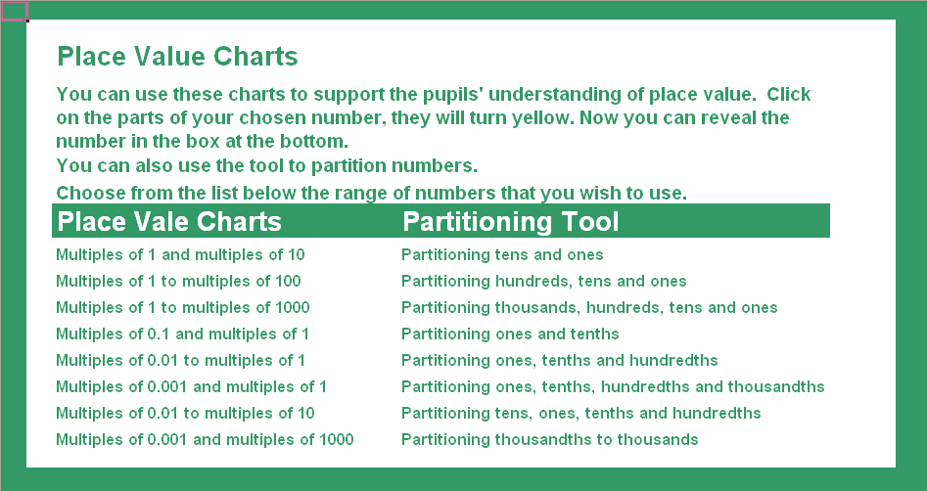

Place value charts - How to use

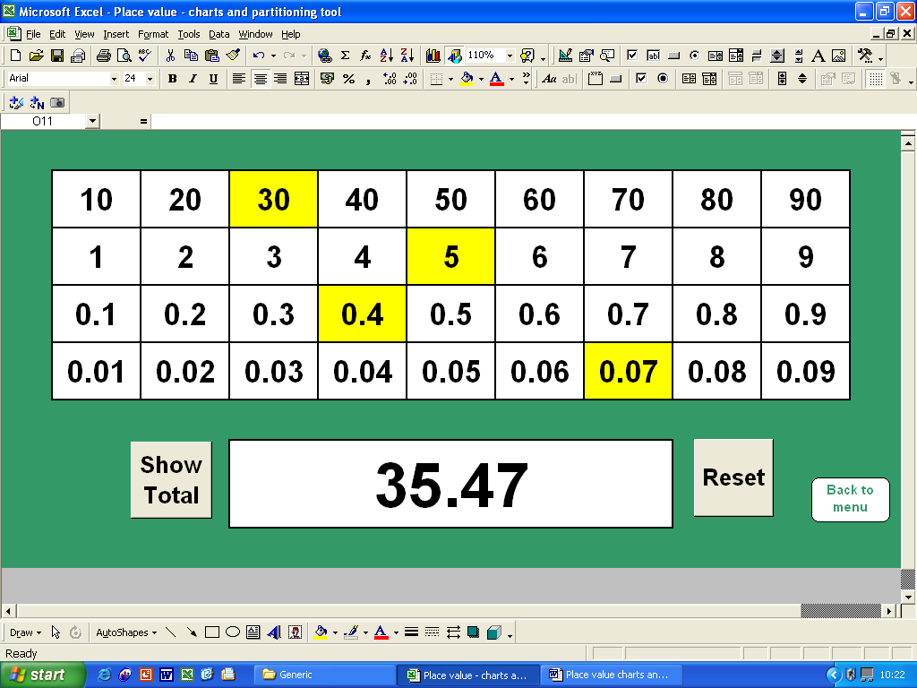
When you click on the white cells they will turn yellow and their contents will be added to the total
A second click will remove them from the total
The total of the highlighted cells will automatically be calculated here

Click here to reveal the total of the highlighted cells
Click here to clear the chart and the total to start again

Click here to return to the main menu

Place value charts - Key questions and prompts

- What number will I make if I combine these?
- Which cells do I need to highlight if I want to make the number 11.04?
- Give me an example of a number that will not have a cell highlighted in the second row.
- If I want to change the number to 34.47, what will I need to change?
- How can I add 0.1 to this number?
- Tell me some numbers that I can create with just two clicks?
- What is the highest number that I can make? ... and the lowest?
- If I add another row to my chart, below the bottom row, what numbers will it contain?
- Highlight 45. What is 45 ÷ 10? What changes do I need to make to the cells to show 4.5? What will happen if I divide 4.5 by 10? How can I use the chart to find 38.6 ÷ 10?

Partitioning tool - How to use

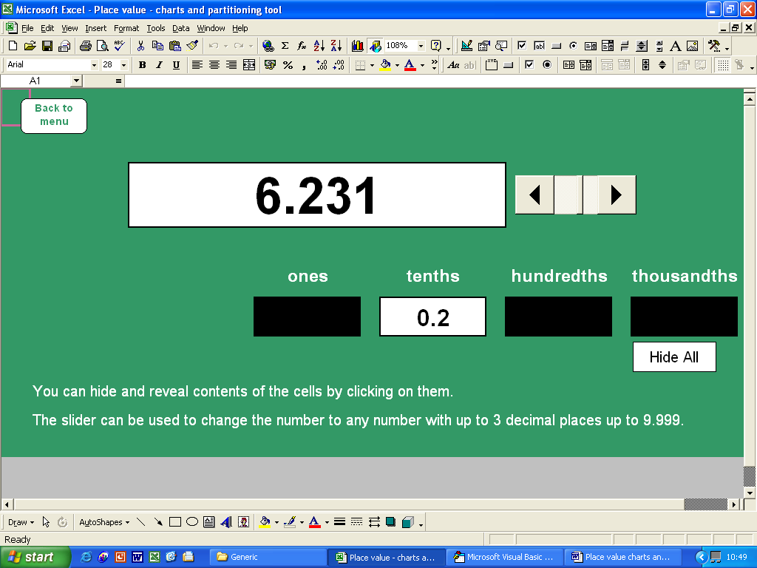
Click here to return to the main menu
Use the slider to change the number that you are going to partition

Click on the cells containing the numbers to hide and reveal their contents
Click here to hide all of the numbers
You can then reveal the number that you are going to partition before you change it

Partitioning tool - Key questions and prompts

- How many tenths are there in this number?
- What will be hidden behind each black rectangle?
- What is the value of this digit?
- What will happen if I change the number to 6.232? ... What about if I change it to 6.331?
- Tell me a number that will have no hundredths.
- Watch what happens to the parts of the number as I gradually increase the number by 0.001 at a time?
- What about if I decrease it?
- What number will I get if I add 1 tenth ... 2 tenths ... 3 tenths etc?
- If this digit is reduced by 3 – what impact does that have on the whole number?
- Tell me some numbers that have 9 tenths.

