Thermometer

This ITP displays a thermometer. The scale, range and the interval markers can be changed and a slider control can be dragged up and down the length of the thermometer to set the height of the column. A second marker indicates the last reading so that comparisons can be made. This marker can be fixed in position if required. The positive or absolute difference between two values can be displayed, and the change in the temperature as the marker is moved. The ITP can be used to develop children’s understanding of vertical scales and negative numbers in the context of temperature. The slider controls can be used to introduce and model strategies for addition and subtraction that involve positive and negative numbers. The language of number can be developed, giving meaning to calculations such as subtract negative 3 from negative 7.

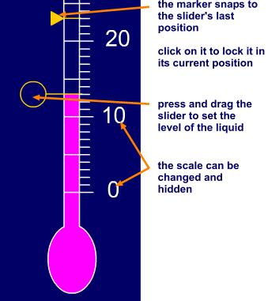

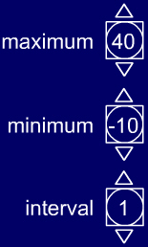 | Use the pointers to adjust the way the scale is displayed.  Maximum from –20 to 50  Minimum from –30 to 40  The interval markers on the scale can be displayed at every 1, 2, 5, or 10. |        | Fix or unfix the position of the marker.  Hide or show the value indicated by the slider.  Show or hide the absolute difference in value between the slider and the marker (always a positive value).  Show or hide the change in value between the slider and the marker (can be a negative value).

