Can I multiply one-digit and two-digit numbers by 10 and 100?

Teaching guidance

Key vocabulary
place value, digit, units, ones, tens, hundreds, thousands, one-digit number, two-digit number, multiply, place holder

Models and images
Place value grid
0  0  Th  H  T  U  3  5  5  3 | Use digit cards to make numbers in the grid. Show how each digit in a number moves one column to  the left when a number is multiplied by 10 and two columns to the left when it is multiplied by 100.

Moving digits ITP
Use the Moving digits ITP to model the effect of multiplying and dividing a number by 10 or 100. | 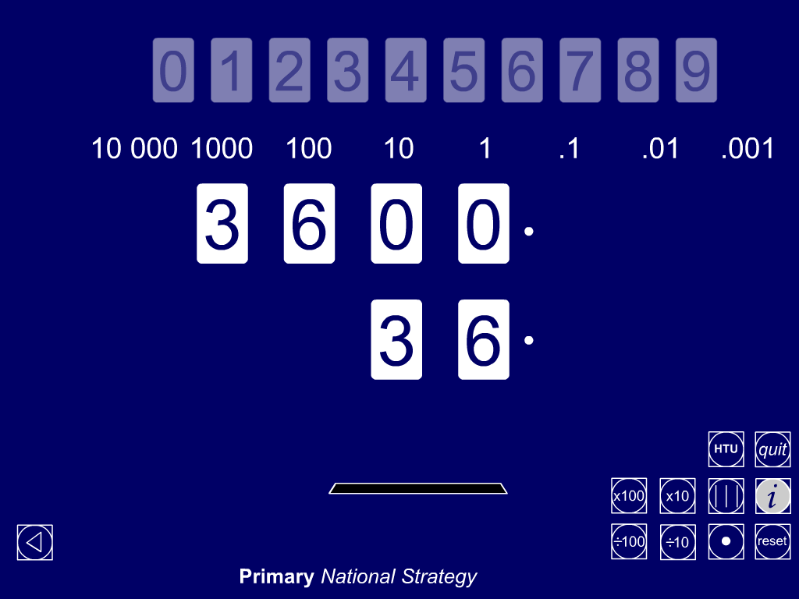

Calculators
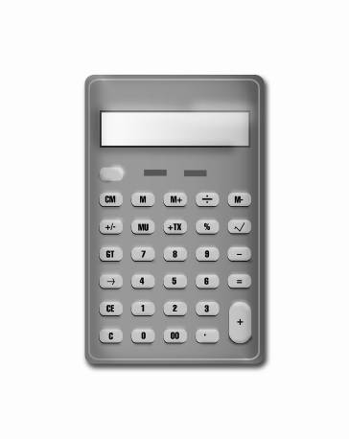 | Use an overhead calculator to demonstrate to children how each digit in a number moves to the left as you multiply a number by 10 or 100.  Show children how to set a constant function so that they can enter different start numbers, predict and then check the answer when the number is multiplied by 10 or 100.

Teaching tips

- Before teaching children how to multiply numbers by 10 and 100, ensure that they can confidently read and write numbers to 10 000. They should also be able to partition numbers and state the value of each digit in a given number.

- Build from what children already know. Write:
1 × 10 = 10 1 × 100 = 100
2 × 10 = 20 2 × 100 = 200
3 × 10 = 30… 3 × 100 = 300
Continue the pattern.
Ask: What do you notice?

- Use practical equipment, such as straws grouped in ones, tens and hundreds or £1, 10p and 1p coins, to reinforce children’s understanding of the relative values of hundreds, tens and ones. Children need to understand and be able to use the fact that 10 ones make one ten, 10 tens make one hundred and 100 ones make one hundred. Ask questions such as:
- How many 10p coins are worth the same as these three £1 coins?
- How many tens do you need to make 280? How many ones do you need?

- Avoid using the explanation that you ‘add a zero’ when you multiply a number by 10 or ‘add two zeros’ when you multiply a number by 100. Instead, stress the following.
- Multiplying by 10 gives an answer that is bigger than the original number and all the digits move one place to the left.
- Multiplying a whole number by 10 will leave a gap in the units column which you need to fill with a zero. Similarly, multiplying a whole number by 100 leaves gaps in the units and tens columns which you need to fill with zeros.
- These zeros are called ‘place holders’. Without the zero place holder, the number 560, for example, would say 56. The zero is important, because it holds the other digits in the right place so that you know their correct value.

- Ensure that children understand that multiplying by 10 and then by 10 again is equivalent to multiplying by 100. One way to reinforce this is for children to work in pairs using calculators. Both key in the same start number. One child multiplies by 10, then multiplies the answer by 10 again. The other multiplies the number by 100. They compare answers.

- It is important that children fully understand how to multiply numbers by 10 as this is a key strategy in multiplication. For example, to work out:
- 13 × 30, children could multiply 13 by 10 then multiply the answer by 3;
- 6 × 16, children could find 6 × 10 and 6 × 6, then combine the answers.

