Doubling and halving

Overview
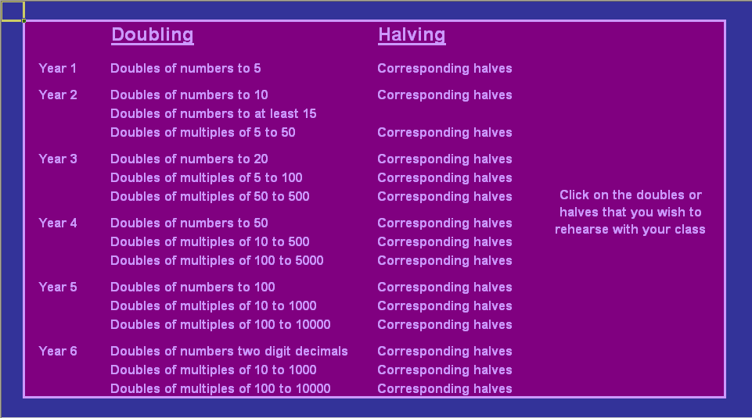
This program enables children to practise doubling and halving. On the first sheet you click on the type of numbers that you want to work with and whether you want to double or halve (see right). Then you use the simple spreadsheet to randomly generate numbers to be doubled or halved. The results can then be checked.

How to use the program
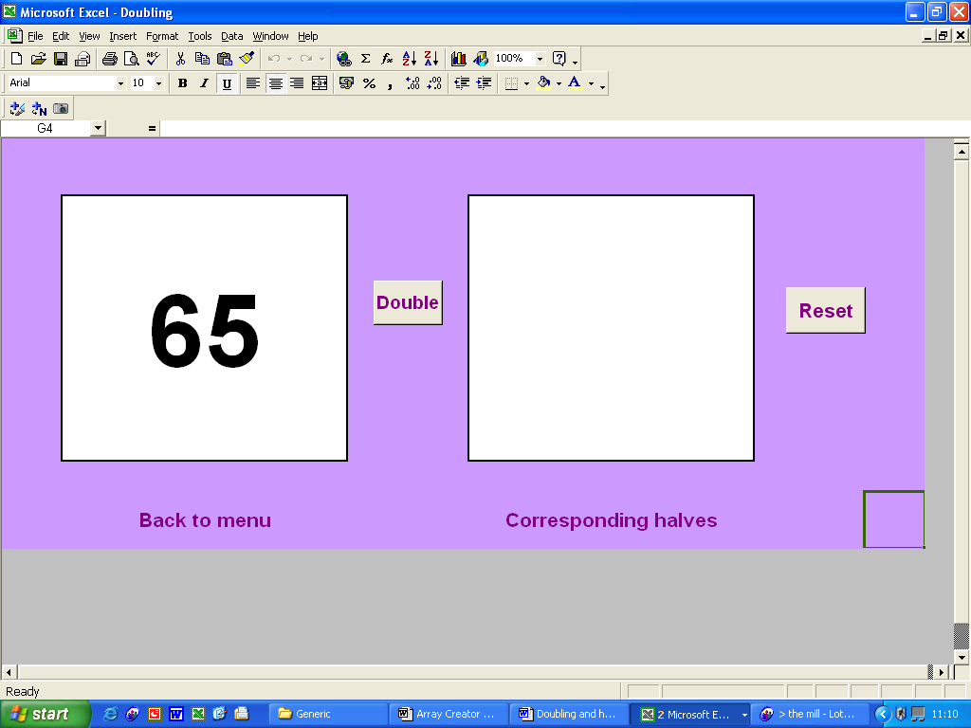
Click here to place a new random number in the first box.
Use this button to double (or halve) the number and reveal the answer in the right-hand box.

Click here to work with the same type of numbers but change the operation from doubling to halving (or vice versa).

Click here to return to the main menu.

Key questions and prompts
- What is double 65?
- How can we write this as a number sentence? Is there another way?
- How did you work it out?
- Is there another strategy that we could use?
- Can we use this to help us with any other facts? (What about double 650 or double 6.5?)
- What is double 70? … double 75? … double 80? Can you spot a pattern?
- Which numbers are hard to double? Why?
- Close your eyes. I am thinking of a number. If I double it I get 120.
What was my number?
- What numbers will give an answer between 120 and 140 when they are doubled?
How did you work that out?
- What is half of 61? How else could we express this? What about half of 30.5?
What about half of 15.25?

This guide is designed to support the use of the spreadsheet throughout Key Stage 2. Consequently some of the key questions and prompts may not be appropriate for children on the border of level 2 and 3.

